|  |
| --- |
| 新东方在线英语学习 |
| 新概念 1 册 |
| Lesson105-106 |



扫一扫。更多有趣的英语资讯。

# Lesson 105 单词讲解

1. spell: 拼写si bi you

spell-spelt-spelt

How do you spell “…”?

1. intelligent: 聪明的，有智慧的in tai lei zhen te

clever: adj. 聪明的（含贬义）

brilliant: adj. 极端聪明的bu rui lian te

talented: 有才能的、有天赋的tei len tei te

1. mistake: 错误
2. a mistake
3. two mistakes 犯错误：

make a mistake

他在考试中犯了好多错误。

He made many mistakes in the exam.

1. present: 礼物pu ruai zen t

a birthday present a Christmas present

1. dictionary: 词典

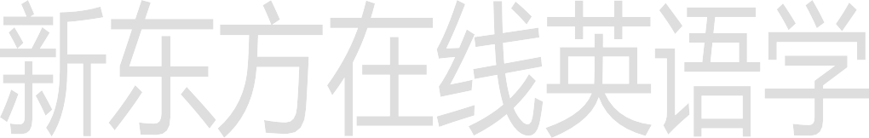English-Chinese dictionary Chinese-English dictionary e- dictionary

He is a walking dictionary.

他是个活字典。

# Lesson 105 课文讲解

1. 错误百出

full of mistakes

他的数学试卷错误百出。

His math paper full of mistakes. His math paper is full of mistakes. be full of mistakes

1. You’ve typed it with only one “L”. with:
   1. 和…在一起

I am with my mom.

* 1. 带有、具有

a house with a garden

a book with a green cover

* 1. 以…方式，用

We hear with our ears. We see with ours eyes.

* 1. 对于，至于…

What are you going to do with that…? What’s the matter with you?

1. I’m sorry about that. about:
   1. 关于…

a book about Chinese history

* 1. …怎么样？(询问或提意见) What about you? What about a drink?

Sorry about it\that.

动词不定式：

1. 构成：to do

want to do want sb. to do tell sb. to do ask sb. to do

# Lesson 105 语法讲解

…



2. 使用：

他想买一辆新车。

He wants to buy a new car.

我想让你试一试。

I want you to try it.

我想让他移一下他的车。 I want him to move his car. 告诉他快点回来。

Tell him to go back right now.

1. 成分：

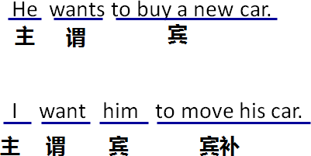

宾语承接谓语的动词，宾补是承接宾语

1. 不定式的否定：

want sb. to do- don’t want sb. to do tell sb. to do- tell sb. not to do

ask sb. to do- ask sb. not to do

…

我不想让他担心。

I don’t want him to worry about me.

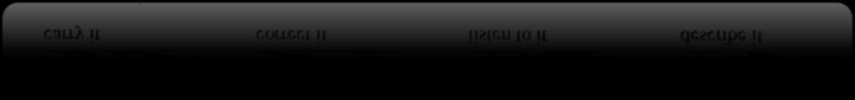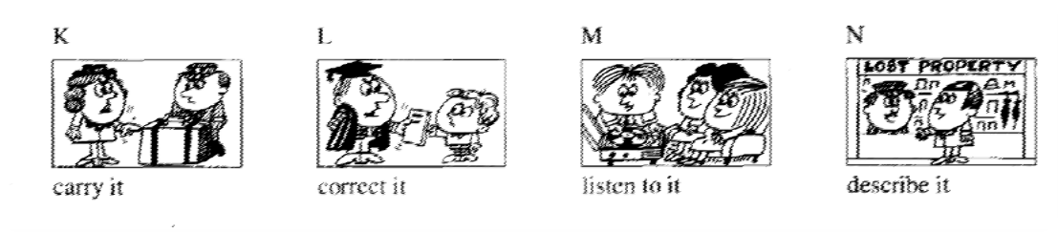

I want you to carry it.

跟他说不要送礼物了。

Tell him not to give present.

# Lesson 106 单词句型讲解

1. carry: 携带、运送bring: 带 来 take: 带走

fetch: 去了再回来，取

1. May I my boyfriend here next time，mom?

A. bring B. take C .fetch D. carry 2). A taxi them to the station yesterday.

A. fetched B. brought C. took D. carried 3). Please the umbrella with you. It’s going to rain.

A. bring B. take C .fetch D. carry 4). The day before yesterday, he us some good news.

A. fetched B. brought C. took D. carried 5). The boss says to her, “please me my documents

in that room”.

A. fetch B. bring C. take D. carry

1. correct: 改正，纠正

Please correct the mistake you have made on the paper.

1. keep: 保存、保留

keep— kept— kept

I have kept the old photo for a long time. Keep in touch. 保持联络。

He wants you to correct it. He wants us to listen to it. He wants me to describe it

She doesn’t want him to slip. Tell him not to fall.

Tell him not to miss it.

1. 常见的缩写：

want to…= wanna…

# Lesson 105&106 知识拓展

I want to have a big house in Beijing. I wanna have a big house in Beijing. thanks=thx

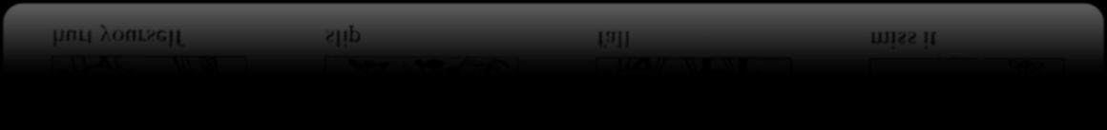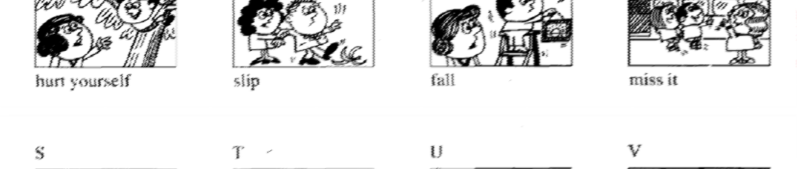

I don’t want you to hurt yourself.

kind of = kinda



going to= gonna

1. 简单但地道的口语：
   1. got it？

明白没？

* 1. You wish!

想的美！

1. So what?

那又怎么样呢？

1. No way!

没门！

1. No offence.ao fan si

没有冒犯的意思。

1. Eyes front!

朝前看。

1. Good point！

说的好！

D. All right.

没关系。